CareerSource Escarosa
Workforce Innovation and Opportunity Act
(WIOA) Two-Year Modification:
Workforce Services Plan
January 1, 2027 – December 31, 2028

CareerSource Board / Planning Region | Submission Option | Date Submitted
CareerSource Escarosa  Region One (1)  www.careersourceescarosa.com | X Standard Local Plan + Regional Addendum  ☐ Preferred Combined Regional Plan | October 6, 2026  by 4:00 p.m.CT/5:00 p.m. EDT
Marcus McBride, PhD, CEO | (850) 607-8700 x288 | mmcbride@careersourceescarosa.com
Tarae Donaldson, MPA, COO | (850) 607-8787 | tdonaldson@careersourceescarosa.com

Table of Contents
- Required Evidence and Certification Checklist 3-5
- Regional Plan Requirements — Streamlined Framework 6-30
- Local Plan Addendum Requirements — Streamlined Framework 30
- Strategic Alignment Framework 38-42
- Performance Dashboard and Improvement Plan 43
- Apprenticeship and Employer Engagement Scorecards 45-49
- Attachments 50

Required Evidence and Certification Checklist
Attach or link the documents below. Narrative is only required to identify changes, gaps, pending updates, or documents expiring within six months of submission.
Evidence Item | Required? | Submitted / Linked | Change Since Prior Plan? | Notes / Expiration Date
Executed Interlocal Agreement | Yes, if applicable | https://careersourceescarosa.com/wp-content/uploads/2026/05/2026-Interlocal-Agreement-1.pdf | X Yes ☐ No | Expires:  June 30, 2030
Executed CLEO–LWDB Agreement | Yes | https://careersourceescarosa.com/wp-content/uploads/2026/05/2026-Interlocal-Agreement-1.pdf | X Yes ☐ No | Expires:  June 30, 2030
Fiscal Agent Designation | If other than CLEO | https://careersourceescarosa.com/wp-content/uploads/2026/02/Florida_Commerce_Agreement_Executed.pdf | X Yes ☐ No
Current Bylaws | Yes | https://careersourceescarosa.com/wp-content/uploads/2026/07/Signed-07.22.2026-CSE-ByLaws.pdf | X Yes ☐ No | Last Review:  July 22, 2026
Board Roster, Minutes, and Vote | Yes | https://careersourceescarosa.com/board-and-committee-meetings/ | X Yes ☐ No
Organizational Chart with Required Roles, Apprenticeship Navigator, and Hope Navigator | Yes |  | X Yes ☐ No | See Attached
One-Stop Partner MOUs and Infrastructure Funding Agreement | Yes | https://careersourceescarosa.com/wp-content/uploads/2026/05/Community-Action-Program-Committee.pdf  https://careersourceescarosa.com/wp-content/uploads/2026/02/Signed-MOU-Between-Workforce-Escarosa-and-the-Florida-DOE-Division-of-Blind-Services.pdf  https://careersourceescarosa.com/wp-content/uploads/2026/05/Division-of-Vocational-Rehabilitation.pdf  https://careersourceescarosa.com/wp-content/uploads/2026/02/Signed-Memorandum-of-Understanding-Between-Workforce-Escarosa-Inc.-dba-CareerSource-Escarosa-and-The-National-Caucus-Center-on-Black-Aged-Inc_.pdf  https://careersourceescarosa.com/wp-content/uploads/2026/05/Pensacola-State-College.pdf  https://careersourceescarosa.com/wp-content/uploads/2026/02/2024-2027-SBEC.pdf  https://careersourceescarosa.com/wp-content/uploads/2026/05/MOU-SRCSD-2.pdf  https://careersourceescarosa.com/wp-content/uploads/2026/05/Tri-County-Community-Council.pdf | X Yes ☐ No | Pending full execution of updated MOU/IFA by Division of Blind Services and NCBA
Firewalls / Conflict Mitigation Documentation | If applicable |  | X Yes ☐ No | N/A
Planning Region Agreements | For regional plan |  | X Yes ☐ No
Public Comment Documentation | Yes | ☐ | X Yes ☐ No | Pending
Staff Training and Credentialing Evidence | Yes | ☐ | X Yes ☐ No
Plan Review Checklist | Recommended | ☐ | X Yes ☐ No

Regional Economy and Labor Market

Regional Takeaways: Escambia & Santa Rosa Counties (2025)
The Escambia-Santa Rosa region continues to experience steady population and economic growth. Combined population reached approximately 544,800 residents in 2025, with more than 33,000 new residents added since 2020 and an additional 28,000 projected by 2030. Employment also expanded, adding nearly 16,200 jobs over the past five years, bringing total regional employment to more than 226,000 jobs.
Growth has been stronger in Santa Rosa County, which experienced a 12.0% population increase and 13.4% employment growth, both exceeding national trends. Escambia County also saw positive gains, with population increasing by 3.3% and employment growing by 6.1%.
Educational attainment data indicates both counties have a larger share of residents with Associate Degrees than the national average, while Bachelor's Degree attainment remains slightly below national levels. This highlights the importance of technical education, industry certifications, and workforce training programs in supporting regional talent needs.
The region's economy is supported by a diverse mix of industries, including restaurants and food services, federal government and military, education and healthcare, financial services, and retail trade. Median household income varies significantly between the two counties, with Santa Rosa County exceeding the national median and Escambia County trailing it, reflecting opportunities to improve wage growth and economic mobility.

Workforce Implications
The region's continued population and job growth signal increasing demand for skilled workers across key industries. However, declining labor force participation rates in both counties suggest a need to engage more residents in the workforce. Workforce development efforts should focus on expanding talent pipelines, increasing credential attainment, connecting underutilized populations to employment, and supporting career pathways that lead to higher-wage occupations. Strategic investments in training, upskilling, and employer partnerships will be essential to meeting workforce demand and sustaining the region's long-term economic growth.

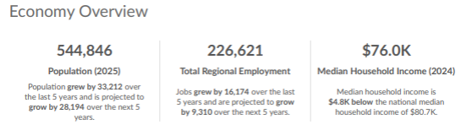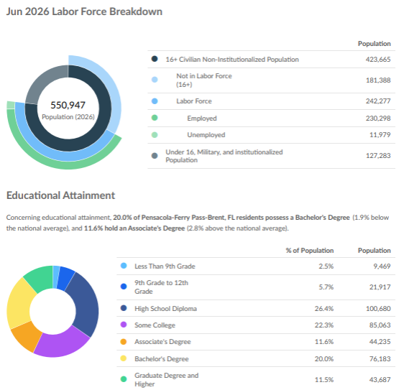

Figure 1: Economy Overview, Labor Force Breakdown, Educational Attainment
(Source: UWF Haas Center, Lightcast Q3 2026 Data Set)

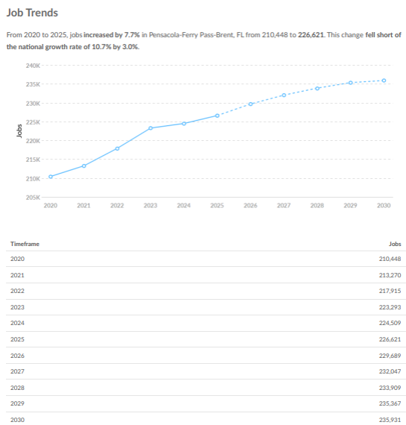
Figure 2: Job Trends
(Source: UWF Haas Center, Lightcast Q3 2026 Data Set)

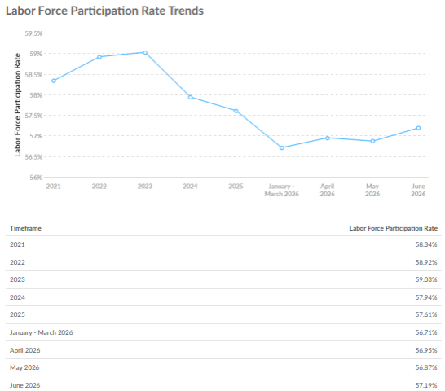
Figure 3: Labor Force Participation Rate Trends
(Source: UWF Haas Center, Lightcast Q3 2026 Data Set)

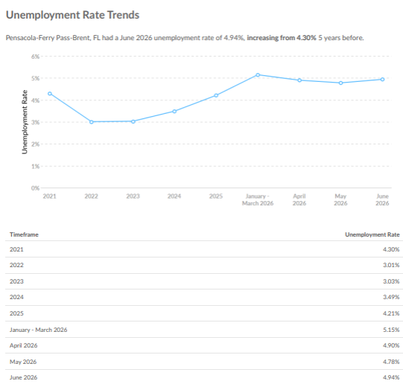
Figure 4: Unemployment Rate Trends
(Source: UWF Haas Center, Lightcast Q3 2026 Data Set)

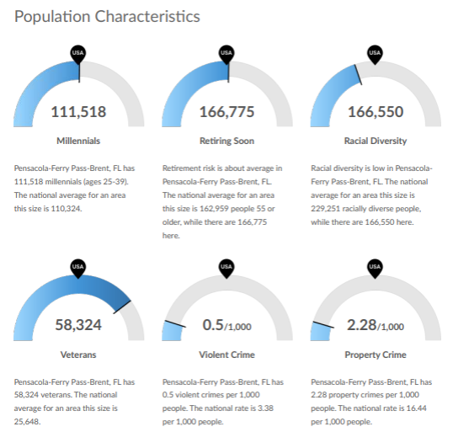
Figure 5: Population Characteristics
(Source: UWF Haas Center, Lightcast Q3 2026 Data Set)

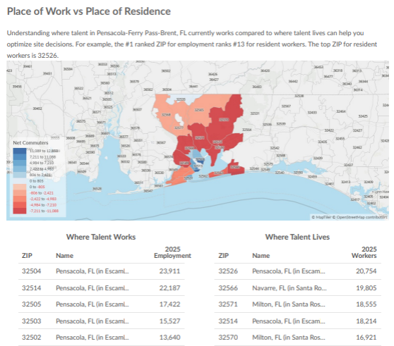
Figure 6: Place of Work v Place of Residence
(Source: UWF Haas Center, Lightcast Q3 2026 Data Set)

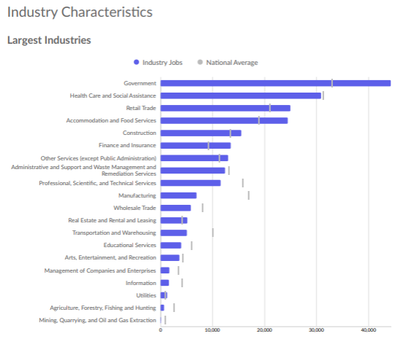
Figure 7: Largest Industries
(Source: UWF Haas Center, Lightcast Q3 2026 Data Set)

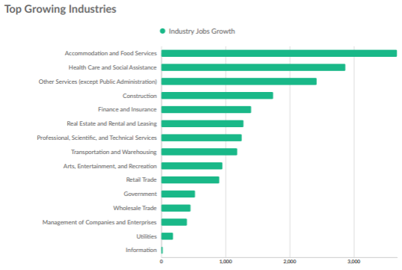
Figure 8: Top Growing Industries
(Source: UWF Haas Center, Lightcast Q3 2026 Data Set)
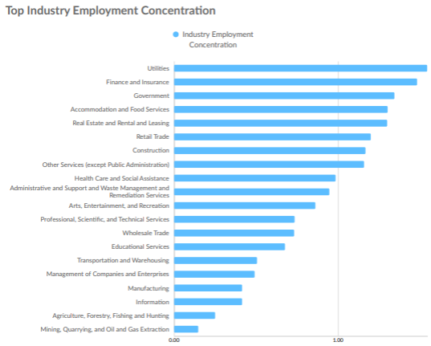
Figure 9: Top Industry Employment Concentration
(Source: UWF Haas Center, Lightcast Q3 2026 Data Set)

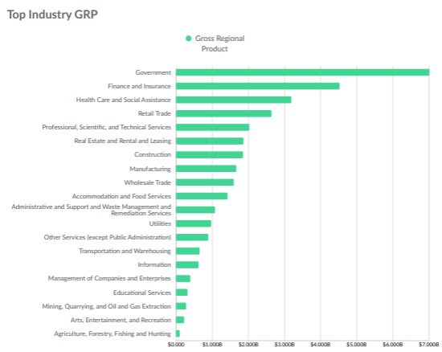
Figure 10: Top Industry Gross Regional Product
(Source: UWF Haas Center, Lightcast Q3 2026 Data Set)

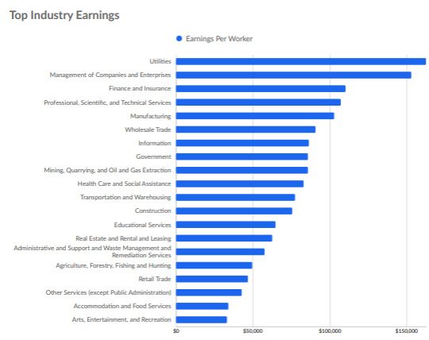
Figure 11: Top Industry Earnings
(Source: UWF Haas Center, Lightcast Q3 2026 Data Set)

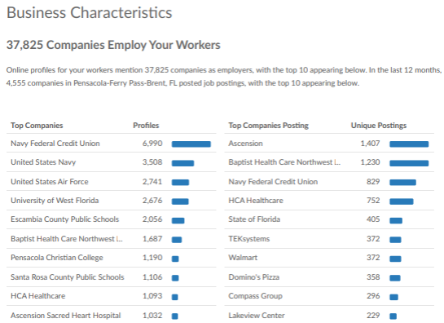

Figure 12: Business Characteristics
(Source: UWF Haas Center, Lightcast Q3 2026 Data Set)

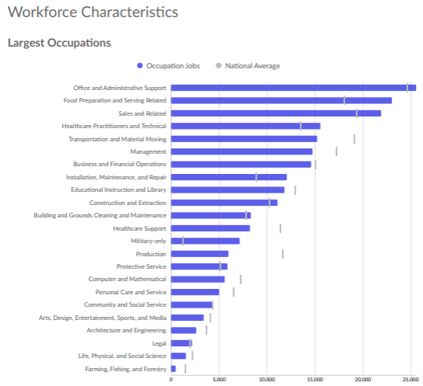
Figure 13: Largest Occupations
(Source: UWF Haas Center, Lightcast Q3 2026 Data Set)

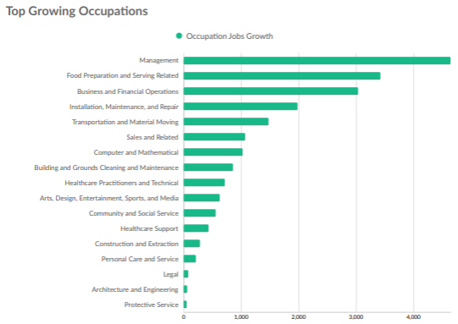
Figure 14: Top Growing Occupations
(Source: UWF Haas Center, Lightcast Q3 2026 Data Set)

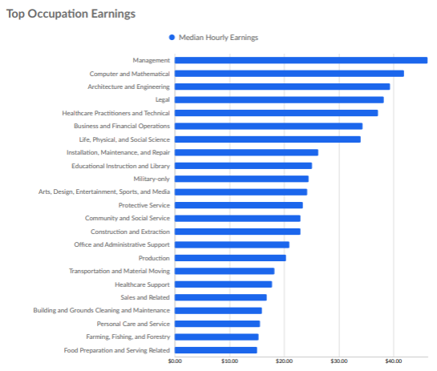
Figure 15: Top Occupation Earnings
(Source: UWF Haas Center, Lightcast Q3 2026 Data Set)

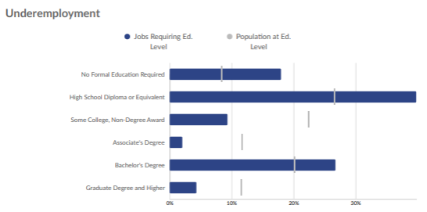

Figure 16: Underemployment
(Source: UWF Haas Center, Lightcast Q3 2026 Data Set)
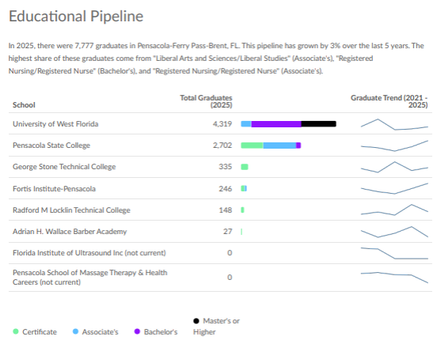
Figure 17: Educational Pipeline
(Source: UWF Haas Center, Lightcast Q3 2026 Data Set)

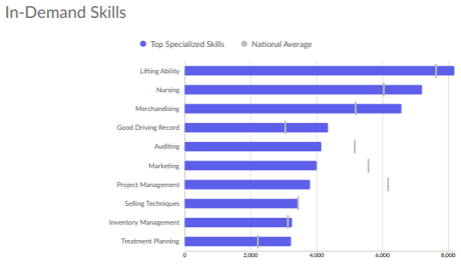
Figure 18: In-Demand Skills
(Source: UWF Haas Center, Lightcast Q3 2026 Data Set)

Regional Service Delivery and Customer Experience
The NFWC utilizes common training providers and supports customer access to training opportunities across the Regional Planning Area when appropriate, including training delivered outside local workforce board boundaries. While each Local Workforce Development Board (LWDB) maintains responsibility for local approval of Eligible Training Providers through its ETPL application process, the NFWC encourages collaboration to expand access to high-quality training resources throughout the region. With the recent addition of the Capital Region as the fifth LWDB in the Regional Planning Area, the NFWC has expanded its efforts to evaluate and align training resources, service delivery strategies, and customer support across all participating regions.
As part of its ongoing regional alignment efforts, the NFWC has inventoried supportive service offerings across all participating LWDBs to establish a baseline for coordination and identify opportunities for greater consistency in service delivery. This assessment serves as a foundation for addressing service gaps, strengthening supportive service coordination, and improving the customer experience across the region. Currently, all five regions, including the Capital Region, offer transportation assistance, educational testing assistance, work-related uniforms and tools, and assistance with employment- and training-related applications, tests, and certifications. Four of the five regions also provide childcare assistance, housing assistance, needs-related payments, legal aid services, and healthcare referrals. The NFWC will continue working toward greater consistency in supportive service delivery whenever feasible while recognizing the varying needs, resources, and funding levels of each local workforce area.
The NFWC also promotes regional collaboration through shared staff training and professional development opportunities. Developing training curricula, delivering training, and maintaining policies and procedural guidance require significant staff resources. By coordinating these efforts across the Regional Planning Area, the NFWC seeks to maximize efficiency, reduce duplication of effort, and promote consistency in service delivery. Regional training initiatives provide opportunities to share best practices, strengthen staff knowledge and skills, enhance accessibility and service quality, and ultimately improve outcomes for both job seekers and businesses throughout Northwest Florida. The NFWC believes that a coordinated regional training approach will support a more consistent customer experience while fostering innovation and continuous improvement across all five workforce regions.
CareerSource Escarosa is the local workforce development organization serving Escambia and Santa Rosa Counties, Florida. CareerSource Escarosa provides a business-focused customer experience by connecting employers with workforce solutions such as recruitment, OJT, incumbent worker training, apprenticeships, and other hiring and training resources. For job seekers, CareerSource Escarosa provides personalized career guidance, job-matching, training opportunities, and support services designed to help individuals overcome barriers and move into sustainable employment.

Customer Flow and Enrollment – Regional Planning Area
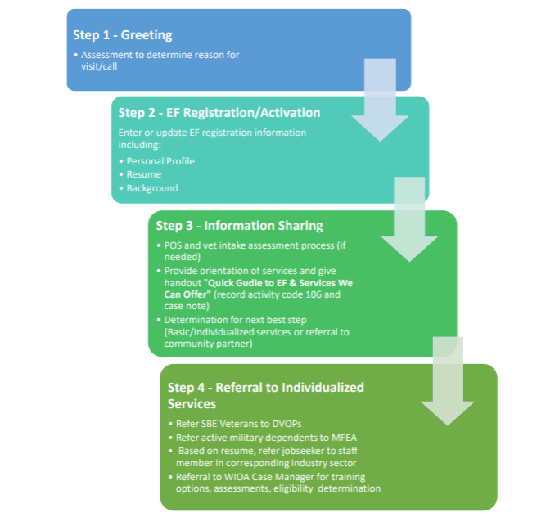

Regional Operations and System Efficiencies
Currently, the five LWDBs do not pool or share administrative costs across the region. While previous regional arrangements included shared staff positions, those models were discontinued through attrition and were not sustained long-term. The boards continue to collaborate through regional agreements and planning efforts and have expressed interest in exploring future opportunities for administrative cost-sharing and resource pooling to improve efficiency. Areas under consideration include shared staffing models, coordinated procurement of goods and services, combined grant administration efforts, and alignment of indirect cost methodologies. Regional partners remain committed to identifying and implementing efficiencies where feasible as the Regional Planning Area (RPA) evolves.

System Efficiencies | Administrative Cost-Sharing Summary | Regional Agreements | Shared Tools/Resources
The five LWDBs currently collaborate through regional planning and coordination efforts but do not formally pool administrative costs. Regional partners are exploring future opportunities for shared staffing, coordinated procurement, combined grant administration, and other efficiency strategies as feasible. | No formal cost-sharing arrangement currently exists. Future opportunities are being evaluated. | Regional planning and coordination agreements support ongoing collaboration. | Shared planning processes, regional meetings, and collaborative grant development efforts.

Regional Performance, Employer Engagement, and Apprenticeship
Performance Negotiation Support
CareerSource Escarosa submitted a request for negotiated performance rates to Florida Commerce by August 10, 2026, based on the unique needs and barriers of the job seekers served in our region. Seven requested rates have been accepted, while the remaining 12 performance categories are still under review.
Negotiations will continue on Tuesday, August 25, 2026, with the goal of establishing performance rates that appropriately reflect the characteristics, needs, and barriers of the customers we serve that may not be accounted for in the current Statistical Adjustment Model (SAM).
Our goal is not to lower expectations, but to establish realistic and meaningful performance standards that allow us to demonstrate progress and continuous improvement. Taking into account the actual needs and barriers of the job seekers we serve will help ensure that our performance targets are both achievable and challenging, while providing a fair measure of our region's progress moving forward.
Letter Grade Improvement Strategies
CareerSource Escarosa’s performance recovery strategy is structured around incremental but measurable quarterly improvements designed to restore all identified indicators to negotiated targets within the allowable two-year timeframe.
The organization anticipates measurable improvement in credential attainment and measurable skill gain indicators within the first six months of implementation due to enhanced enrollment activity, improved provider accountability, and strengthened documentation practices. Median earnings and entered employment indicators are Page 7 of 9
expected to improve over a longer period as employer engagement strategies, OJT expansion efforts, and placement alignment activities mature.
The Board will review all indicators monthly through newly established dashboards and executive oversight meetings to ensure continuous monitoring of progress and timely implementation of corrective actions
Apprenticeship and Pre-apprenticeship Expansion
CareerSource Escarosa will continue expanding registered apprenticeship opportunities by strengthening employer partnerships, increasing participant access to work-based learning, and aligning apprenticeship activities with Florida's targeted industry sectors. The Board is committed to supporting employer-driven workforce solutions that create sustainable career pathways and address regional workforce needs. CareerSource Escarosa plans to become a Registered Apprenticeship Sponsor during Program Years 2026-2027 to expand workforce development opportunities and address critical talent needs across the region.
Sector Partnerships and Talent Pipeline
Through strategic partnerships with organizations such as FloridaMakes, Ascend, Economy Appliance Heating & Air, local healthcare providers, and other industry partners, CareerSource Escarosa is working to develop and support Registered Apprenticeship programs in high-demand occupations, including HVAC, industrial maintenance, mechanical trades, and various healthcare professions. These efforts will create earn-and-learn career pathways, strengthen employer engagement, and provide participants with industry-recognized credentials and sustainable employment opportunities while helping local businesses build a skilled workforce pipeline.
Coordinated Business Services
CareerSource Escarosa's Business Services team partners with employers to address workforce challenges through recruitment, training, and retention strategies. Three key tools used to support local businesses are On-the-Job Training (OJT), job fairs, and employer retention services.
.

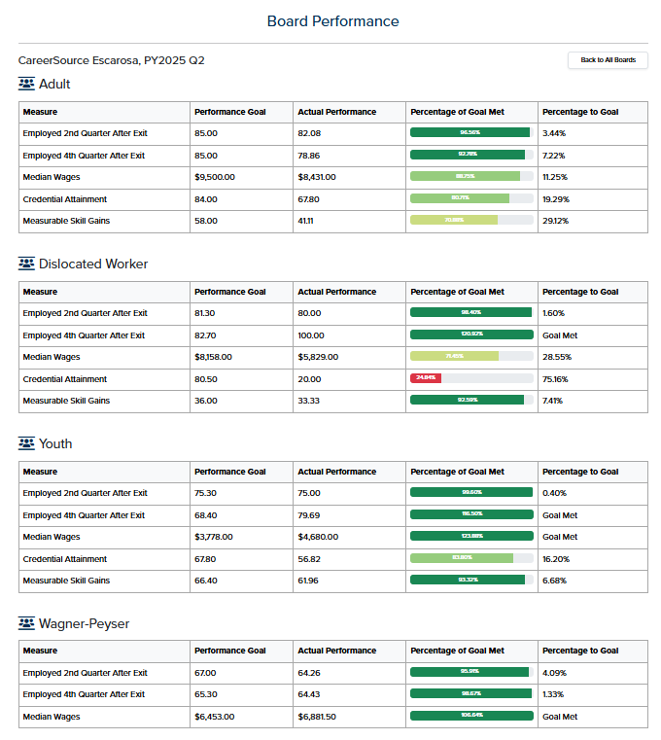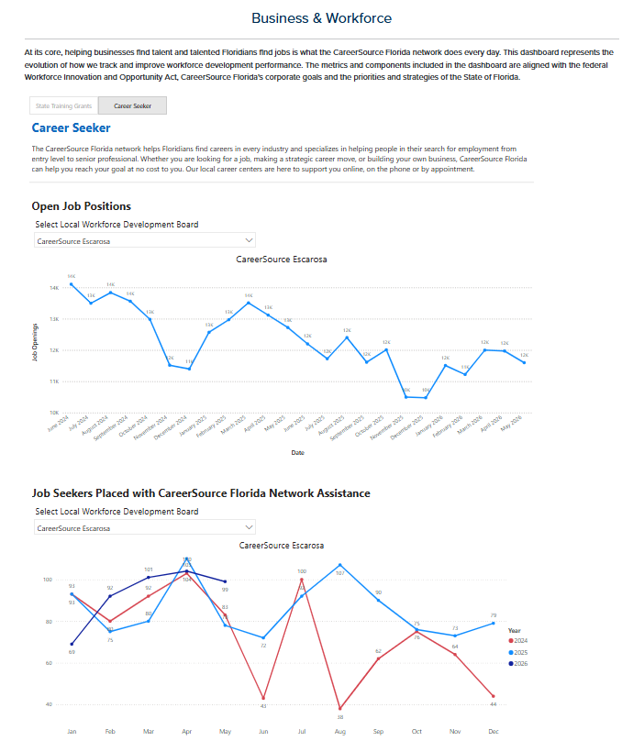

Regional Strategy Summary Table
Priority Area | Shared Regional Strategy | Participating LWDBs / Partners | Measure of Success | Evidence / Attachment
Targeted Industries / Sector Partnerships | Align industry sectors across the region based on labor market demand and employer needs; coordinate sector partnership efforts in high-growth industries. | CareerSource Escarosa, neighboring LWDBs, economic development organizations, chambers of commerce, industry associations, employers, education partners. | Number of sector partnerships established; employer engagement; industry-led workforce initiatives; job placements within targeted sectors. | Sector partnership agreements, meeting minutes, employer participation lists, labor market reports, MOUs.
Coordinated Service Delivery | Standardize service delivery approaches and referral processes to improve customer access and outcomes across the region. | LWDBs, One-Stop partners, community-based organizations, educational institutions. | Number of shared referrals; customer satisfaction; reduced service duplication; increased co-enrollments. | Referral protocols, customer flow charts, partner meeting notes, Crosswalk reports, shared outreach materials.
Supportive Services Coordination | Coordinate supportive service resources to reduce barriers to employment and training participation. | LWDBs, social service agencies, transportation providers, housing organizations, community partners. | Number of participants receiving supportive services; improved retention and completion rates. | Supportive service policies, referral logs, partner agreements, participant outcome reports.
Administrative Efficiencies | Identify opportunities to streamline administrative processes, reduce duplication, and share resources regionally. | LWDBs, fiscal staff, administrative staff, state partners. | Cost savings; reduced processing times; implementation of shared procedures. | Shared policies and procedures, cost analyses, regional planning meeting documentation.
Coordinated Performance Improvement | Collaboratively analyze performance outcomes and implement regional improvement strategies. | LWDBs, performance teams, program managers, state workforce representatives. | Achievement of negotiated performance measures; measurable improvement in key indicators. | Performance reports, corrective action plans, monitoring reports, regional performance dashboards.
Apprenticeship / Work-Based Learning | Expand apprenticeship, pre-apprenticeship, OJT, internships, and other work-based learning opportunities regionally. | LWDBs, employers, educational institutions, apprenticeship sponsors, workforce partners. | Number of apprenticeships and work-based learning placements; employer participation rates. | Apprenticeship agreements, OJT contracts, participant enrollment records, employer commitment letters.
MCL / Credential Alignment | Align training investments with the Master Credentials List (MCL) and regional workforce demands. | LWDBs, training providers, educational institutions, employers, state workforce partners. | Increase in participants earning credentials aligned with regional demand occupations. | MCL alignment documentation, ITA reports, credential attainment reports, training provider agreements.
Coordinated Business Services | Deliver consistent and collaborative business services to employers across the region through coordinated outreach and engagement. | LWDB Business Services Teams, employers, economic development organizations, chambers, educational partners. | Number of employers served; business service engagements; job orders; repeat employer utilization. | Business engagement logs, employer outreach plans, meeting records, regional business services strategy documents.

Local Plan Addendum Requirements — Streamlined Framework

Governance and Organizational Structure
Updated Changes:
CLEO
Escambia County Board of County Commissioners – Chair
Ashlee Hofberger
221 Palafox Place, Suite 400
Pensacola, FL 32502
850-595-4950
District4@myescambia.com

Santa Rosa County Board of County Commissioners – Chair
Colten Wright
6495 Caroline Street
Milton, FL 32570
850.983.1877
District5@santarosa.fl.gov

LWDB Membership
Rotated Off/Resigned
Jeffrey Hondorp – West Fraser
Michele Kelson – Pensacola Electrical Apprenticeship College
Fred Genkins – Titan Sunrooms
Steven Harrell – Escambia County School District
Lani Burritt – Ex Officio (Santa Rosa County Board of Commissioners)

New Members
Jennifer Hines – Santa Rosa County School District
Justin Marcum – Association of Fire Fighters
Lisa Walsh – Navy Federal Credit Union
Brandi L. Boyd Rutherford – FLDOE/Division of Vocational Rehabilitation
Robert Christopher Plate` - FloridaWest Economic Development Alliance
Leslie Moland – Florida Blue
James Howe – Landrum Workforce Solutions
Chase Horne – Police Benevolent Association
Darnell Powell – AHW Barber Academy
Dixie Bond – Ex Officio (Santa Rosa County Board of Commissioners)

One-Stop Operator
Luis Roman

Delegated Signatory Authority
Lloyd Reshard – CareerSource Escarosa Board Chair
Santa Rosa County Board of County Commissioners – Chief Local Elected Official, Effective: July 1, 2026-June 30, 2027

Analysis of Need and Available Resources (Labor Market Dashboard Above)
The Pensacola-Ferry Pass-Brent region and Santa Rosa County are experiencing continued population and employment growth, creating both opportunities and workforce challenges. Population growth, expanding industries, and projected job creation indicate sustained demand for workers, while declining labor force participation and educational attainment gaps point to the need for targeted workforce development strategies.
Current and Emerging Industry Needs
Employment increased by 7.4% in the Pensacola-Ferry Pass-Brent region between 2020 and 2025, adding 15,564 jobs. Santa Rosa County experienced even stronger growth, adding 6,184 jobs, or 13.4%, exceeding national job growth. An additional 6,632 jobs are projected in the Pensacola-Ferry Pass-Brent region and 3,571 jobs in Santa Rosa County through 2030.
The region's leading industries include restaurants and food services; government and military; education and healthcare; grocery and retail; and financial services. These industries provide a broad range of employment opportunities, from entry-level positions to occupations requiring advanced education, technical credentials, and specialized skills. Continued growth will increase demand for workers with skills in healthcare, education, customer service, management, skilled technical occupations, business operations, and other industry-specific fields.
The concentration of government and military employment also creates opportunities for career pathways connected to defense, public-sector operations, logistics, technology, and related contractors. At the same time, healthcare, education, hospitality, retail, and financial services will require a steady pipeline of qualified workers to support population growth and replacement needs.
Workforce Gaps and Population Barriers
Despite strong employment growth, labor force participation has declined. Participation fell from 58.6% to 57.0% in the Pensacola-Ferry Pass-Brent region and from 58.5% to 56.3% in Santa Rosa County. The decline suggests that population growth and job creation are not fully translating into increased workforce participation. Connecting individuals who are not currently working or seeking work to career services, training, supportive resources, and employers represents a significant opportunity.
Educational attainment is another workforce consideration. Bachelor's degree attainment remains below the national average in both areas, while associate degree attainment exceeds the national average. This indicates a strong foundation for skills-based and career-oriented training,but also highlights the need to expand pathways to bachelor's degrees where occupations require them. Short-term credentials, industry certifications, apprenticeships, and other work-based learning opportunities can provide additional routes into growing occupations without requiring a four-year degree.
Workforce participation may also be affected by barriers such as transportation, childcare, limited access to training, lack of industry-recognized credentials, and challenges transitioning from education or unemployment into sustainable employment. Addressing these barriers will be important to ensure that residents can access available jobs and that employers have access to qualified workers.
Income differences across the region further emphasize the need for accessible career pathways. Median household income is approximately $73,600 in the Pensacola-Ferry Pass-Brent region, below the national median, while Santa Rosa County's median household income is approximately $91,900, above the national median. Workforce investments should therefore prioritize pathways that lead to family-sustaining wages and opportunities for advancement, particularly for residents facing economic barriers.
Available Resources and Workforce Response
The region has several assets that can support workforce development, including a growing employer base, educational institutions, workforce development organizations, career services, and existing employer partnerships. The area's relatively strong associate degree attainment provides a foundation for expanding technical education, industry credentials, and career pathways aligned with employer demand.
Workforce resources should be coordinated around a sector-based, career-pathway approach. Career centers and workforce organizations can connect job seekers to career counseling, job placement, training assistance, and supportive services. Community and technical colleges can align programs and credentials with high-demand occupations, while employers can provide internships, apprenticeships, on-the-job training, and other work-based learning opportunities.
Employer engagement will be particularly important in identifying skill gaps and ensuring training remains responsive to changing industry needs. Partnerships among employers, education and training providers, workforce organizations, and community partners can create clearer pathways from recruitment and training to employment and advancement.

Strategic Alignment and Five Pillars
State Plan / Local Strategy Crosswalk
The Local Workforce Development Board will align its strategic priorities with Florida's workforce vision through five pillars: Industry-Driven Strategies, Worker Mobility, Integrated Systems, Accountability, and Flexibility & Innovation. Together, these pillars provide a framework for building a responsive, customer-centered, and performance-driven workforce system.
1. Industry-Driven Strategies
The Board will strengthen partnerships with employers and industry leaders to ensure workforce investments reflect current and emerging labor-market needs. Employer input and regional labor-market information will guide training priorities, sector strategies, and work-based learning opportunities. The Board will continue expanding OJT, IWT, EWT, apprenticeships, and other employer-driven strategies that connect customers directly to employment opportunities.
2. Worker Mobility
The Board will support individuals in gaining the skills, credentials, and experience necessary to obtain employment and advance along career pathways. Strategies will emphasize high-demand occupations, stackable credentials, career advancement, apprenticeships, supportive services, and transferable skills. Services will be designed to help individuals enter employment, remain employed, and move toward greater economic self-sufficiency.
3. Integrated Systems
The Board will promote a seamless workforce system by strengthening coordination among workforce programs, education and training providers, employers, community partners, and other agencies. Co-enrollment, coordinated referrals, shared processes, and improved case management will help reduce duplication and ensure customers are connected to the full range of available services.
4. Accountability
The Board will maintain a strong culture of performance, fiscal responsibility, data integrity, and continuous improvement. Leadership and program managers will routinely monitor WIOA performance indicators, negotiated performance rates, credential attainment, measurable skill gains, expenditures, employment outcomes, and other key measures. Performance gaps will be addressed through targeted action plans, technical assistance, staff development, and ongoing monitoring.
5. Flexibility & Innovation
The Board will remain responsive to changing economic conditions, employer needs, customer barriers, and emerging workforce opportunities. The local system will leverage labor-market intelligence, technology, virtual service delivery, innovative partnerships, and pilot strategies to improve access and outcomes. Successful approaches will be evaluated, refined, and scaled when supported by performance data.
Overall Strategic Alignment
The five pillars work together to create a workforce system that is employer-led, customer-focused, integrated, accountable, and adaptable. The Board's local strategy will align resources and partnerships around measurable outcomes while maintaining the flexibility necessary to respond to regional economic changes and the evolving needs of workers and employers.

Program Services and Partner Coordination
Partner Matrix
Partner / Program | Primary Services Provided | Coordination with CareerSource Escarosa | Evidence / Documentation
WIOA Adult | Career, training, supportive, and employment services | Shared case management, referrals, co-enrollment, career pathways | MOU, LOPs, case management records
WIOA Dislocated Worker | Reemployment, training, supportive services | Rapid reemployment, training referrals, supportive services coordination | MOU, training records, co-enrollment reports
WIOA Youth | Education, training, work experience, career exploration | Joint service delivery with schools and youth-serving organizations | MOU, work experience records, youth program reports
Temporary Assistance for Needy Families | Employment and self-sufficiency services | Joint case management, referrals, co-enrollment, supportive services | DCF agreements, referral data, co-enrollment reports
SNAP E&T | Employment and training services for SNAP recipients | Shared customer referrals, training coordination, employment services | SNAP E&T agreements, referral reports
Jobs for Veterans State Grant (JVSG) | Veteran-specific employment services | Referrals between Wagner-Peyser, WIOA, and JVSG staff | JVSG procedures, veteran service reports
Unemployment Insurance (UI) | Reemployment assistance, claims support | RESEA referrals, workforce service referrals, employment workshops | RESEA reports, referral documentation
Senior Community Service Employment Program (SCSEP) | Employment and training services for older workers | Referrals, employment support, training coordination | MOU or referral procedures
Community Services Block Grant (CSBG) | Supportive services, emergency assistance | Shared customers, referrals for housing, transportation, and support services | Partner agreements, referral reports
HUD/Housing Partners | Housing assistance, homelessness services | Referrals, supportive services coordination, employment support | MOU, referral tracking
Perkins V / Career and Technical Education (CTE) | Career and technical education pathways | Career pathway development, training referrals, employer engagement | School district agreements, partnership records
Pensacola State College | Postsecondary education and occupational training | Training provider coordination, credential attainment, career pathways | MOU, ETPL participation records
George Stone Technical College | Technical education and occupational skills training | Training referrals, credential attainment, workforce alignment | Training provider agreements
Escambia County School District | Adult education, CTE, career pathways | Youth services, dual enrollment, career awareness activities | MOU, joint initiatives
Santa Rosa County School District | Adult education, CTE, career pathways | Workforce preparation, youth and career pathway coordination | MOU, partnership activities
Vocational Rehabilitation (VR) | Employment services for individuals with disabilities | Co-enrollment, referrals, supportive service coordination | Executed MOU, referral reports
Division of Blind Services (DBS) | Employment and training services for individuals who are blind or visually impaired | Referrals, co-case management, training coordination | Executed MOU, referral documentation
Early Learning Coalition | Childcare assistance and early learning support | Childcare referrals supporting training and employment participation | Referral records, partner agreements
Children's Home Society of Florida | Youth and family support services | Referrals, supportive service coordination, youth service integration | MOU, referral reports
Crosswalk Agency Referral System Partners | Community-based support services | Electronic referrals, coordinated service delivery, warm handoffs | Crosswalk reports, referral data
Economic Development Organizations & Chambers | Business engagement and labor market alignment | Employer outreach, sector strategies, workforce solutions | Partnership agreements, meeting records
Employers and Apprenticeship Sponsors | Work-based learning, OJT, apprenticeships, employment opportunities | OJT, EWT, IWT, apprenticeships, hiring events | OJT agreements, apprenticeship records
Exceptions Narrative
CareerSource Escarosa coordinates service delivery through formal MOUs, referral processes, co-enrollment strategies, and Local Operating Procedures with core and combined partners. Partners collaborate to provide workforce, education, training, employment, and supportive services through an integrated service delivery model. Referral and co-enrollment activities are supported through partner communication, case coordination, and the Crosswalk Agency Referral System when applicable. Certain partner services, such as housing assistance, childcare assistance, and specialized disability services, remain under the authority of the respective partner agency; however, CareerSource Escarosa coordinates access through referrals and collaborative case management to ensure customers are connected to the full range of available services. The Board continues to strengthen coordination among workforce, education, human-service, and economic-development partners to reduce duplication and improve customer outcomes.

One-Stop Delivery System
Addressed in the Plan, Organizational Structure Section, Pages 5-9

Access Point Table
Access Point | Services Available | Customer Access | Accessibility Features | Technology & Integration | Significant Changes Since Prior Plan
CareerSource Escarosa Pensacola Career Center (Comprehensive One-Stop) | WIOA Adult, DW, Youth, Wagner-Peyser, JVSG, RESEA, training services, business services, workshops, supportive-service referrals | In-person, phone, email, website | ADA-compliant facility, assistive technology, language assistance, accessible parking and entrances | Employ Florida, virtual workshops, electronic records, Crosswalk referrals, Teams and online meeting platforms | Expanded virtual services, increased referral coordination, enhanced technology utilization
CareerSource Escarosa Milton and Century Career Centers (Affiliate Sites) | Career services, job search assistance, employer recruitment, workshop access, referrals | In-person, phone, virtual appointments | ADA-compliant facility and accommodations | Shared case management systems, Employ Florida access, virtual services | Continued integration with regional and virtual service delivery
Virtual Service Delivery | Job search assistance, career coaching, workshops, orientations, employer interviews, training information | Website, email, telephone, virtual meeting platforms | Remote access for customers unable to travel; accessibility tools available through virtual platforms | Teams, webinar platforms, online forms, electronic document exchange | Expanded significantly to improve access and service flexibility
Partner Locations (VR, DBS, DCF, SNAP E&T, CHS, ELC, etc.) | Specialized employment, supportive, educational, and human services | Referral and co-location opportunities where available | Partner-specific accessibility accommodations | Crosswalk Agency Referral System, coordinated referrals, warm handoffs | Increased partner coordination and referral tracking
Educational Partners (Pensacola State College, George Stone Technical College, School District Programs) | Education, occupational training, credential attainment, career pathways | In-person and online training options | ADA accommodations and student support services | Shared training provider coordination, ETPL alignment | Expanded pathway and credential alignment efforts
Employer Sites / Work-Based Learning Locations | OJT, apprenticeships, pre-apprenticeships, work experience, incumbent worker training | Employer-based service delivery | Employer-specific accommodations as applicable | Employer engagement systems, apprenticeship coordination, electronic agreements | Expanded employer-driven training opportunities

Employer Engagement, Sector Strategies, and Apprenticeship

Performance and Continuous Improvement
Improvement Strategies
CareerSource Escarosa has developed a comprehensive improvement strategy
designed to directly address each identified root cause area through coordinated
operational, governance, and service delivery enhancements.

The organization will expand credential attainment efforts by strengthening enrollment
pipelines into training programs, improving participant follow-up procedures, and
standardizing credential reporting requirements across all providers. Increased
utilization of the MyCSE Scholarship process and streamlined enrollment pathways will
support greater participation in credential-bearing activities.

To address measurable skill gain deficiencies, CareerSource Escarosa has
implemented weekly performance reviews focused specifically on MSG tracking and
documentation accuracy. Staff training initiatives are being expanded to ensure all
workforce personnel understand documentation requirements and performance
expectations related to interim skill gains and participant progression milestones.
Enhanced provider accountability measures are also being implemented for youth
service providers. Monthly provider performance meetings are now being conducted to
review outcomes, identify barriers, and implement corrective strategies where
necessary. Provider scorecards and enhanced monitoring protocols will support ongoing
accountability and continuous improvement.
Employer engagement efforts are also being significantly expanded. CareerSource
Escarosa intends to aggressively promote OJT utilization through increased employer
outreach, board member engagement, and strategic partnerships with high-growth
industry sectors. The organization will leverage available state OJT reimbursement
incentives to encourage greater employer participation and increase opportunities for
higher-wage employment placements.

Co-Enrollment and System Integration Strategy
CareerSource Escarosa will implement a structured co-enrollment strategy to improve
participant outcomes by aligning individuals across multiple eligible workforce programs
where appropriate. This approach is intended to reduce fragmented service delivery,
improve training completion rates, and strengthen employment outcomes through
coordinated service access. The organization will strengthen cross-program referral
processes, increase collaboration between internal program teams, and utilize shared
case management coordination to ensure participants receive comprehensive support
services aligned with their individual employment and training needs.

Partnership Enhancement Strategy
The LWDB will continue strengthening collaboration with workforce system partners and
expanding integrated service delivery models across the region. This includes
enhancing coordination with workforce stakeholders, specifically Florida Division of
Vocational Rehabilitation and Division of Blind Services, to improve referral alignment,
reduce duplication of services, and increase participant access to high-quality training
and employment pathways. Both partners are already in our Crosswalk Agency Referral
System, which has streamlined the referral process for 2025 and 2026; however, we
plan to further enhance our partnership for better outcomes. CareerSource Escarosa
will also continue developing strategic partnerships with community-based
organizations, education providers, economic development entities, and employer
partners to improve participant access, support service coordination, and long-term
employment success.

Operationally, CareerSource Escarosa has already implemented daily leadership
huddles focused on key performance indicators and weekly management-by-exception
reporting processes. Semi-monthly meetings with the WIOA Program Manager and
monthly PIP Committee meetings have also been established to ensure continuous
monitoring of performance recovery efforts.
Additionally, the organization is developing integrated performance dashboards and
conducting routine case file audits to improve real-time visibility into participant
outcomes, credential attainment, measurable skill gains, and wage progression trends.

Improvement Targets
CareerSource Escarosa’s performance recovery strategy is structured around
incremental but measurable quarterly improvements designed to restore all identified
indicators to negotiated targets within the allowable two-year timeframe.
The organization anticipates measurable improvement in credential attainment and
measurable skill gain indicators within the first six months of implementation due to
enhanced enrollment activity, improved provider accountability, and strengthened
documentation practices. Median earnings and entered employment indicators are
expected to improve over a longer period as employer engagement strategies, OJT
expansion efforts, and placement alignment activities mature.
The Board will review all indicators monthly through newly established dashboards and
executive oversight meetings to ensure continuous monitoring of progress and timely
implementation of corrective actions.

Strategic Alignment Framework
Five Pillar | Statewide Priority / Requirement | Local or Regional Strategy | Key Partners | Measure / Target | Evidence / Attachment
Industry-Driven Strategies | Employer engagement, sector strategies, in-demand occupations, targeted industries, OJT, apprenticeship, preapprenticeship, MCL alignment | Align investments with employer demand and high-growth industries. Build a demand-driven workforce system. Expand employer partnerships; increase OJT/IWT/EWT; align training with labor-market data. Employer engagement; work-based training; placements; credentials; satisfaction. | Employers; Chambers of Commerce; Economic Development; community/technical colleges; CTE; apprenticeship sponsors. | Employer engagement; work-based training; placements; credentials; employer satisfaction. | - Employer Engagement Scorecard  - Apprenticeship & Employer Engagement Scorecard  - Business Services annual report  - Labor Market Information dashboard  - OJT/IWT/EWT performance reports  - Sector partnership meeting minutes  - Chamber and Economic Development partnership documentation  - ETPL/MCL alignment reports  - Credential attainment dashboard  - Employer satisfaction survey results
Worker Mobility | Credential attainment, career pathways, supportive services, reduced public assistance, wage progression | Support skills, credentials, employment, and career advancement. Create clear career pathways. Expand training/apprenticeships; strengthen coaching; supportive services; stackable credentials. Training completion; credentials; MSGs; employment; retention; wage progression. | Employers; colleges/technical schools; apprenticeship programs; Vocational Rehabilitation; Division of Blind Services; supportive-service partners. | Training completion; credentials; MSGs; employment; retention; wage progression. | - Credential attainment dashboard  - Measurable Skill Gain (MSG) reports  - Training completion reports  - Employment and earnings performance reports  - Supportive services utilization reports  - Apprenticeship and pre-apprenticeship participation data  - Co-enrollment and referral reports  - Vocational Rehabilitation and Division of Blind Services partnership documentation  - Employer retention and wage progression outcome
Integrated Systems | Core and combined partner coordination, regional service delivery, education/workforce/economic development alignment | Coordinate workforce, education, human services, and community partners. Deliver seamless, coordinated services. Strengthen referrals/co-enrollment; shared processes; case coordination; partner communication. Referrals; co-enrollment; customer flow; coordination; satisfaction; employment. | DCF/TANF; SNAP; Early Learning Coalition; Crosswalk Agency Referral System partners; Vocational Rehabilitation; Division of Blind Services; Children's Home Society; Escambia & Santa Rosa School Districts. | Referrals; co-enrollment; customer flow; coordination; satisfaction; employment. | - Crosswalk Agency Referral System reports  - One-Stop Partner MOUs and IFAs  - DCF/TANF and SNAP E&T referral and co-enrollment data  - Vocational Rehabilitation and Division of Blind Services referral outcomes  - Children's Home Society partnership documentation  - Escambia and Santa Rosa School District collaborative initiatives  - Partner coordination meeting minutes  - Customer flow and service delivery process maps  - Co-enrollment and case management reports  - Customer and partner satisfaction survey
Accountability | Federal performance indicators, letter grades, ROI, performance improvement actions, data quality | Promote performance, fiscal stewardship, and data integrity. Use data for continuous improvement. Monitor performance; improve data quality; track expenditures; implement corrective actions. WIOA indicators; negotiated rates; MSGs; expenditures; data accuracy; PIP progress. | FloridaCommerce; CareerSource Florida; LWDB leadership; One-Stop Operator; MIS/RSO; program managers; service providers. | WIOA indicators; negotiated rates; MSGs; expenditures; data accuracy; PIP progress. | - WIOA performance dashboards and scorecards  - FloridaCommerce negotiated performance reports  - Letter grade reports and improvement strategies  - Internal monitoring results and corrective action plans  - Data validation and case file review reports  - Board and committee performance reports  - Financial audits and expenditure reports  - Staff training and technical assistance records  - Performance Improvement Plan (PIP) documentation
Flexibility and Innovation | Regional efficiencies, shared services, technology, innovative training, customer access, continuous improvement | Adapt to changing labor-market and customer needs. Maintain a responsive workforce system. Pilot innovations; expand virtual services; use real-time data; develop new partnerships; adjust strategies. New initiatives; participation/outcomes; access; response time; partnerships; strategies sustained. | Employers; education/training providers; community organizations; economic development; technology partners; local government. | New initiatives; participation/outcomes; access; response time; partnerships; strategies sustained. | - Innovation project summaries  - Customer access and utilization dashboards  - Virtual service participation reports  - Employer and customer satisfaction surveys  - Regional collaboration agreements  - Labor market intelligence reports  - New partnership MOUs or agreements  - Program evaluation reports  - Continuous improvement action plans  - Pilot project outcome reports

Performance Dashboard and Improvement Plan
Measure | Negotiated Level / Target | Actual Performance | Status | Primary Cause / Driver | Improvement Action
Employment Rate 2nd Quarter After Exit | 82.10%/ 89.40% | 82.10% | Needs Improvement | Skills gaps, transportation barriers, and housing instability limit employment attainment after program exit. | Conduct monthly participant follow-up to support retention, address barriers, and verify employment outcomes.
Employment Rate 4th Quarter After Exit | 82.00%/ 88.30% | 86.90% | Needs Improvement | Employment retention is affected by transportation challenges, housing costs, and concentration in high-turnover industries. | Maintain monthly follow-up and connect participants to supportive services that promote long-term employment stability.
Median Earnings 2nd Quarter After Exit | $9000/ $11,040 | $8,252 | Needs Improvement | Many participants enter lower-wage occupations due to limited work experience, barriers to employment, or entry-level placement. | Provide ongoing career coaching, advancement planning, and training opportunities that support wage progression.
Credential Attainment Rate | 75%/ 88.50% | 81.90% | Needs Improvement | Training completion is impacted by academic, financial, transportation, and personal barriers. | Monitor training progress monthly and intervene early to support completion and credential documentation.
Measurable Skill Gains | 50%/ $54.40% | 60.20% | Needs Improvement | Participant barriers and training interruptions can delay progress toward educational and occupational milestones. | Track progress through regular case management, document gains promptly, and provide timely support when issues arise.
State Accountability Letter Grade | Achieve A rating | C | Needs improvement | Performance across workforce, business, and self-sufficiency measures. | Monitor quarterly metrics; implement corrective action for any measure below target.
Return on Investment / Wage Growth | Unknown | N/A | Needs improvement | Low available wages based on the target markets. Many participants have targeted in demand industries, but offer lower-wage occupations. | Increase training aligned with high-demand industries and strengthen employer partnerships.
Public Assistance Transition Outcomes | N/A | Need from SAM | Needs Improvement | Barriers to employment and self-sufficiency among participants. | Expand Co-enrollment in WIOA programs, supportive services, career coaching, and employment retention follow-up.
Business Services Outcomes | Increase employer engagement and repeat business customers. | Consistently meeting this goal | On Track | Employer outreach and responsiveness to workforce needs. | Conduct targeted business outreach and strengthen sector partnerships.
Apprenticeship/Preapprenticeship Outcomes | 138 | 170 (regionally) | On Track | Availability of employer sponsors and participant awareness. | Expand apprenticeship promotion, employer recruitment, and education partnerships.
Performance Improvement Narrative
- What is performing well? Identify the strongest results and the strategies driving those results.
Employer Partnerships Leading to Better Placement Outcomes | Active employer outreach and relationship management.
Expanded Participant Pipeline Through Online Orientation | Offering orientation virtually provides greater flexibility and accessibility.
Successful Launch of the New Workshop Model | Standardized workshop content ensures all participants receive core employability and career development services.
Improved Workforce Readiness and Career Preparation | Integration of job search, resume development, interviewing, and career exploration into workshops.

- What is underperforming or at risk? Identify data points, root causes, populations, programs, or service gaps requiring improvement.
Underperforming or at risk areas | Data points | Root Causes | Populations | Strategies
All elements of Dislocated Workers | Based on the Monthly Management Report Dashboard, CSE Dislocated Worker Denominator varies from 3 to 6 depending on the Measure. | Small participant counts make performance outcomes highly sensitive to individual results. | Dislocated workers | Strengthen eligibility screening and enrollment processes to increase the number of qualified Dislocated Worker participants.
Employment rates at 2nd and 4th quarter | Based on 2024 Actual levels of Performance, CSE is 82.10% and 86.90% (respectively) which are below recent negotiated levels. | Skills gaps, transportation challenges, and housing instability affect employment attainment and retention. | WIOA Adult | Provide employment retention workshops, ongoing participant follow-up, and supportive service referrals to improve long-term employment outcomes.
WIOA Youth Credential Attainment | Based on the Monthly Management Report Dashboard, CSE Youth Credential Rate is currently at 20% which is significantly lower the negotiated rate in 2024 of 75%. | Educational barriers, transportation issues, family responsibilities, and housing instability hinder credential completion. | WIOA Youth | Increase provider collaboration, staff training, and participant monitoring to support credential completion and documentation.

- What actions will be taken? Identify no more than five priority actions, responsible parties, timelines, and expected outcomes.
Action | Responsible Party | Timeline | Expected Outcome
Increase MSG attainment | WIOA Program Manager | Quarterly | Increased MSG attainment
Increase employer outreach in target sectors | Business Services Manager | Q2-Q3 | More job placements
Increase OJT opportunities | Business Services Manager | Q1-Q2 | Increase MSG and credential attainment
Strength follow-up services | WIOA Program Manager | Ongoing | Higher retention rates
Increase WIOA Youth training and engagement | WIOA Program Manager | Ongoing | Improve credential attainment rates among WIOA Youth

9. Apprenticeship and Employer Engagement Scorecards

9A. Employer Engagement and Sector Strategy Scorecard
Measure | Current Baseline | Target | Priority Sector(s) | Key Actions | Evidence / Data Source
Employers Served | 4,714 | 5500 | Healthcare,  aviation/aerospace,  manufacturing,  construction,  information  technology | Expand  employer  outreach  through the  Greater  Pensacola  Chamber,  Workforce  Wednesdays,  FloridaWest,  and direct  business  engagement | Employ Florida  business  services  reports;  chamber  activity reports
Repeat / Retained Business Customers | 711 | 960 | All targeted  industries | Implement  quarterly follow-up with  employers and  expand account  management | Employ Florida  customer  activity report
New Business Customers | 98 | 118 | Healthcare,  construction,  manufacturing,  professional  services | Increase  outreach to  employers not  currently using  workforce  service | Employ Florida;  CRM tracking
OJT Employers | 3 | 7 | Manufacturing,  healthcare,  construction,  aerospace | Expand  promotion of  OJT  reimbursement  opportunities  and conduct  employer  education  campaigns | OJT contracts;  program  enrollment  report
Sector Partnerships | 3 | 6 | Healthcare,  manufacturing,  aerospace,  construction,  maritime,  information  technology | Establish  industry  roundtables and  strengthen  education and  economic  development  partnerships | Meeting  records;  memoranda of  understanding;  partnership  agreement
Employer Referrals to Training | 9 | 10 | Healthcare,  manufacturing,  construction | Increase  referrals to  Incumbent  Worker  Training, OJT,  and customized  training  programs | Training  program  records;  Employ Florida
Market Penetration | 11.26% | 16% | Targeted industries  identified in the  local plan | Increase the  percentage of  employers  receiving  workforce  services within  priority sectors | Employ Florida;  labor market  data; employer  databases
Business Services to Targeted Industries | 3349 | 4800 | Healthcare,  aerospace,  manufacturing,  construction,  information  technology | Align business  services with  high  -demand  industries and  expand  employer  engagement | Align business  services with  high  -demand  industries and  expand  employer  engagement

9B. Apprenticeship and Work-Based Learning Scorecard
Measure | Current Baseline | 2030 / Plan Target | Targeted Industry or Occupation | Annual Action | Partner / Evidence
New Registered Apprentices | 4 | 138 cumulative apprentices by 2030 (30 annually during the 2027-2028 plan period) | Healthcare, aerospace, advanced manufacturing, construction | Recruit new employers and increase apprentice enrollment through coordinated outreach | Registered apprenticeship data; Florida Department of Education; Employ Florida
Registered Apprenticeship Programs | 8 | 12 | Healthcare, manufacturing, construction, aviation | Identify and recruit new apprenticeship sponsors | Apprenticeship sponsor agreements; program registrations
Registered Preapprenticeship Programs | 0 | 0 | Construction, healthcare, manufacturing | Develop preapprenticeship pathways with educational partners | School district agreements; Pensacola State College; training provider records
OJT Placements | 5 | 25 | Manufacturing, healthcare, construction, information technology | Expand OJT marketing and increase employer participation | OJT contracts; program reports
Work-Based Learning Opportunities | 40 | 160 | Healthcare, aerospace, manufacturing, skilled trades | Expand internships, job shadowing, incumbent worker training, and employer-based learning | Employer agreements; chamber partnerships
Apprenticeship Navigator Activities | 120 | 480 | All targeted industries | Conduct employer outreach, technical assistance, and apprenticeship promotion | Navigator activity logs; outreach reports
Career Center Staff Training on Apprenticeship | 2 | 8 | All sectors | Provide annual apprenticeship training to all career center staff | Staff training records; attendance logs
WIOA Supportive Services for Apprentices | 4 | 16 | Healthcare, construction, manufacturing | Expand supportive services to improve apprentice retention | Supportive services records; case management reports
Apprenticeship Sponsorship | 0 | 4 | Healthcare, construction, manufacturing | Expand supportive services to improve apprentice retention | Supportive services records; case management reports

Local Workforce Development Board | 2030 Cumulative Expected Performance Apprentice Count
CareerSource Escarosa (LWDB1) | 138
CareerSource Okaloosa Walton (LWDB 2) | 47
CareerSource Chipola (LWDB 3) | 19
CareerSource Gulf Coast (LWDB 4) | 27
CareerSource Capital Region (LWDB 5) | 47
CareerSource North Florida (LWDB 6) | 77
CareerSource Northeast Florida (LWDB 8) | 336
CareerSource Citrus Levy Marion (LWDB 10) | 206
CareerSource Central Florida (LWDB 12) | 676
CareerSource Pasco Hernando (LWDB16) | 177
CareerSource Polk (LWDB 17) | 174
CareerSource Suncoast (LWDB 18) | 71
CareerSource Heartland (LWDB 19) | 85
CareerSource Research Coast (LWDB 20) | 125
CareerSource Palm Beach County (LWDB 21) | 109
CareerSource Broward (LWDB 22) | 445
CareerSource South Florida (LWDB 23) | 1012
CareerSource Southwest Florida (LWDB 24) | 439
CareerSource North Central Florida (LWDB 26) | 73
CareerSource Brevard Flagler Volusia (LWDB 27) | 226
CareerSource Tampa Bay (LWDB 28) | 491
*As identified in Figure 2.45 of the State Plan.

